Lab 2: DOSE CALIBRATOR

(I. Rutel, 02/20/12)

Study the following parameters of a dose calibrator:

A. Linearity test (using decay method)
Use the following fictitious measurement data to determine how well the measurements fit exponential decay of Tc-99m. (Use Chi-square)

Day | Time | Measurement (mCi) | Uncertainty (%)
Thursday | 13:00 | 170.00 | 5
 | 16:00 | 120.00 | 5
Friday | 8:40 | 17.00 | 5
 | 16:00 | 8.00 | 5
Saturday | 8:30 | 1.10 | 5
 | 15:00 | 0.50 | 5
Sunday | 10:00 | 0.04 | 5

B. Accuracy test
Use two reference sources (Co-57 and Cs-137); compute the ratio of measured value to predicted value for each source. (Resource: www.nndc.bnl.gov)

C. Geometry
Assay the same radioactive source (Co-57) at different depths of chamber; Compare the results.

D. Response and Sensitivity

D.1. Definitions
(Reference: Suzuki A., Suzuki M.N., and Weis A.M., Analysis of a Radioisotope Calibrator; Journal of Nuclear Medicine Technology, Dec. 1976)

Adopt a standard reference source (SRM) (e.g. Co-60)
Define sensitivity (relative) of the detector for a photon of energy E_{i:}

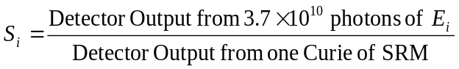

Detector response (relative) from sample A that has several energies:

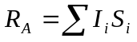

where I_{i} is the intensity of the photon whose energy is E_{i.}

In other words, the response of the detector to radioisotope A relative to that of a standard reference material is:

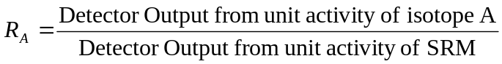

For the Capintec CRC Models (CRC-12, CRC15), the calibration setting (N_{A}) for a radioisotope “A” is linearly related to the relative detector response (R_{A}) of the radioisotope.

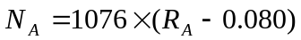
(Reference: Manual of Capintec CRC models)

D.2. Measurements and Computations

(a) Assuming the above linear relationship, compute the ratio of R_{Co-57} to R_{Cs-137}. Compare with prediction from graph of sensitivity.

(b) What happens when wrong calibration factor is used? Answer this question by choosing calibration setting for Co-57 to assay a Cs-137 source. Compare this erroneous measurement with prediction from the linear relationship between calibration setting and detector response.

(c) How much Tc-99m would give approximate equivalent response of 200 mCi of I-131?

Radioisotope | Calibration setting number for Capintec CRC model
Co-57 | 112
Co-60 | 990
Cs-137 | 220
I-131 | 151
Tc-99m | 80

